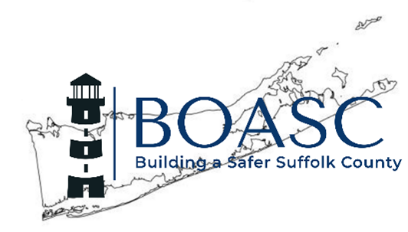

Membership Application

**Application must be filled out completely**

 Active Code Official-$55*  Associate Member-$80

Name:______________________________________________________________________________________________________

Training ID #________________________________________________________________________________________________

Title:_______________________________________________________________________________________________________

Municipality or Company Name:________________________________________________________________________________

Where would you like your mailings to go?

Mailing Address:___________________________________________________________

___________________________________________________________

___________________________________________________________

___________________________________________________________

Phone:___________________________

E-Mail:_________________________________________________________________

Signature_______________________________________ Date__________________

Please return this form along with your dues payment to: Tom Maher
(check or money order only payable to BOASC Village of Lindenhurst
-please do not send cash.) 430 South Wellwood Ave.
Lindenhurst, NY 11757

*To be considered as an Active Code Official you must be currently employed by a municipality in a position that actively enforces the codes of NY State. Yearly dues includes membership in the New York State Building Officials Conference (NYSBOC). This applies only to Code Officials only.

Visit us online at: http://boascliny.org

